SQL Database project

The following will select all the information from the customers:
USE sql_store;
SELECT *
FROM customers;
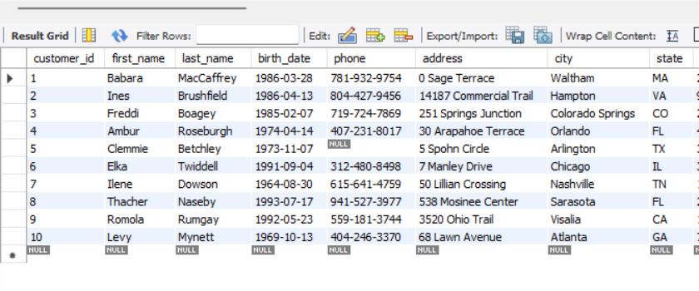
Now we can order the customer’s first name in alphabetical order. You could decide to sort the customers last name, city or any other column containing string characters:
WHERE customer_id = 1
ORDER BY first_name
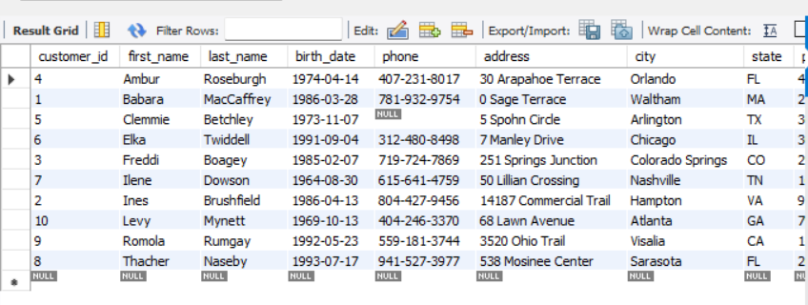

Now we just want to extract the information from the customer’s first and last name, and their points:
- SELECT last_name, first_name, points, points + 10
- FROM customers;

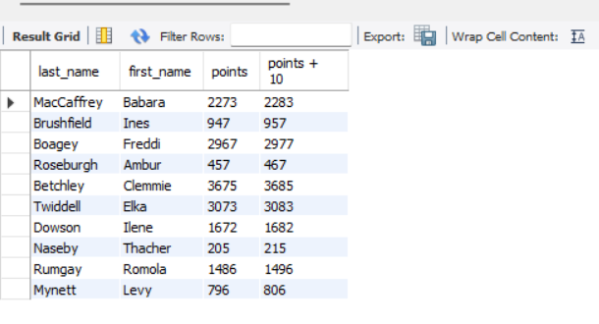
Next writing a query to add a new column named discounted points. Here the points have:
SELECT last_name, first_name, points, (points + 10) * 100 AS discounted_points
FROM CUSTOMERS;
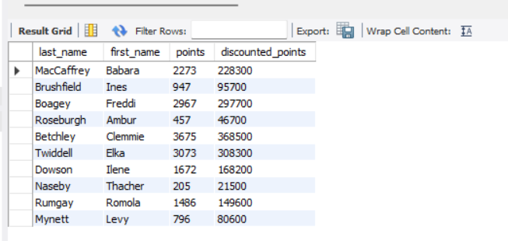

Writing a SQL query to return all the products in our database in the result set. I want to show columns; name, unit price, and new column called new price which is based on this expression, (unit price * 1.1 ).
- So what I am doing is increasing the product price of each by 10%.
- So with the query I want all the products the original price and the new price:
SELECT name, unit_price, ( unit_price) * 1.1 AS new_price
FROM products;

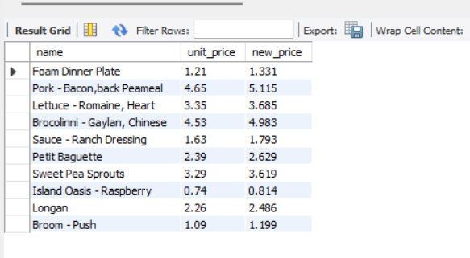
Next query below is to find all the customers where their birthday is after January 1st 1990:
SELECT *
FROM customers
WHERE birth_date > '1990-01-01';
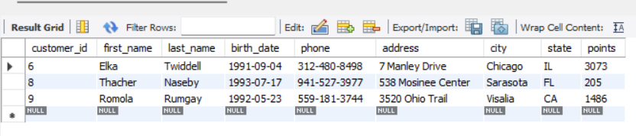

Now I wanted to write a query to show me which products had the most amount of stock:
SELECT *
FROM (products)
ORDER BY quantity_in_stock DESC
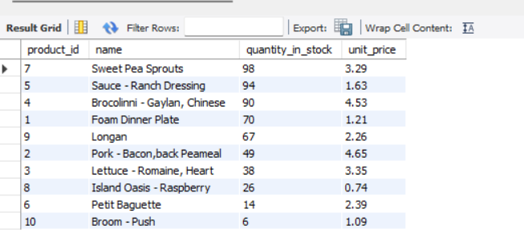
The following query is to find out the most expensive product:
SELECT *
FROM products
ORDER BY price DESC
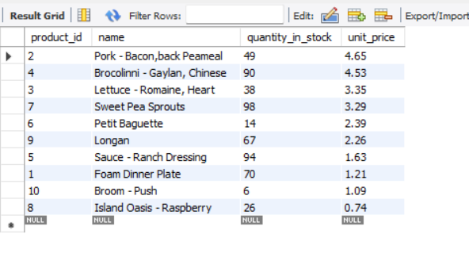

I am now going to write a query to find out the first name, last name, address, and the birthdate of the oldest customer in our dataset:
SELECT *
FROM customers
ORDER BY birth_date ASC
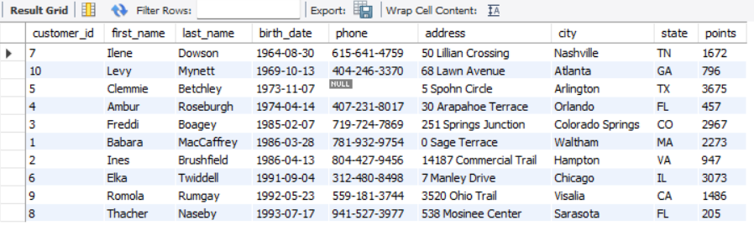

Creating an Enhanced Entity Relationship Diagram (EER)

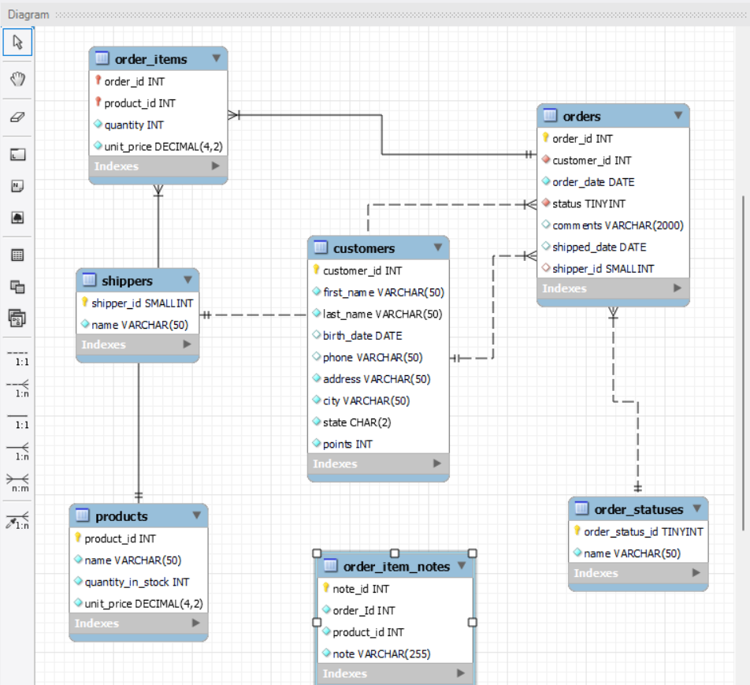

Once the EER has been created, the tables can now be linked to each other. For this, a table must have a primary key (PK), which has to be a unique and can not be a duplicate in the same table. For example, customer id, NHS number, NI number, etc; are all items that will have unique values. Once a PK has been assigned then this can be used as a foreign key (FK) in another table you want to create a relationship with. There can be multiple FKs but only one PK per table in EERs.

